<!DOCTYPE html> <html lang="en"> <head> <meta charset="UTF-8" /> <meta http-equiv="X-UA-Compatible" content="IE=edge" /> <meta name="viewport" content="width=device-width, initial-scale=1.0" /> <title>Document</title> <link rel="stylesheet" href="styles.css" /> </head> <body> <nav class="navbar"> <div class="logo">Andrews</div> <div> <ul class="nav-list"> <li> <a href="">Home</a> </li> <li> <a

{ margin: 0; padding: 0; box-sizing: border-box; } .navbar { display: flex; align-items: center; justify-content: space-between; background-color: salmon; padding: 1rem; }\* { margin: 0; padding: 0; box-sizing: border-box; } .navbar { display: flex; align-items: center; justify-content: space-between; background-color: salmon; padding: 1rem; }

.nav-list { display: flex; } .nav-list li { list-style: none; margin-right: 1rem; } .logo { font-size: 30px; font-weight: 700; }

.nav-list li a { text-decoration: none; color: black; font-weight: 600; }

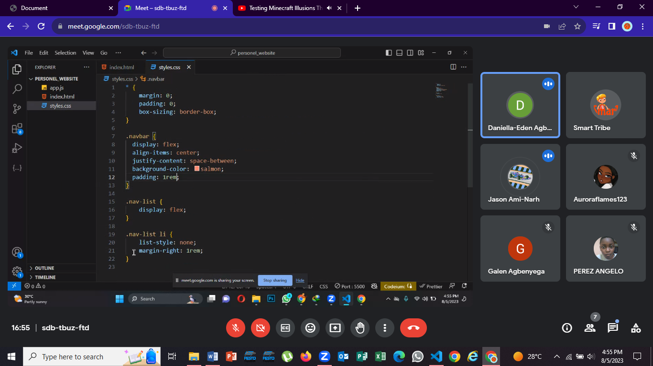 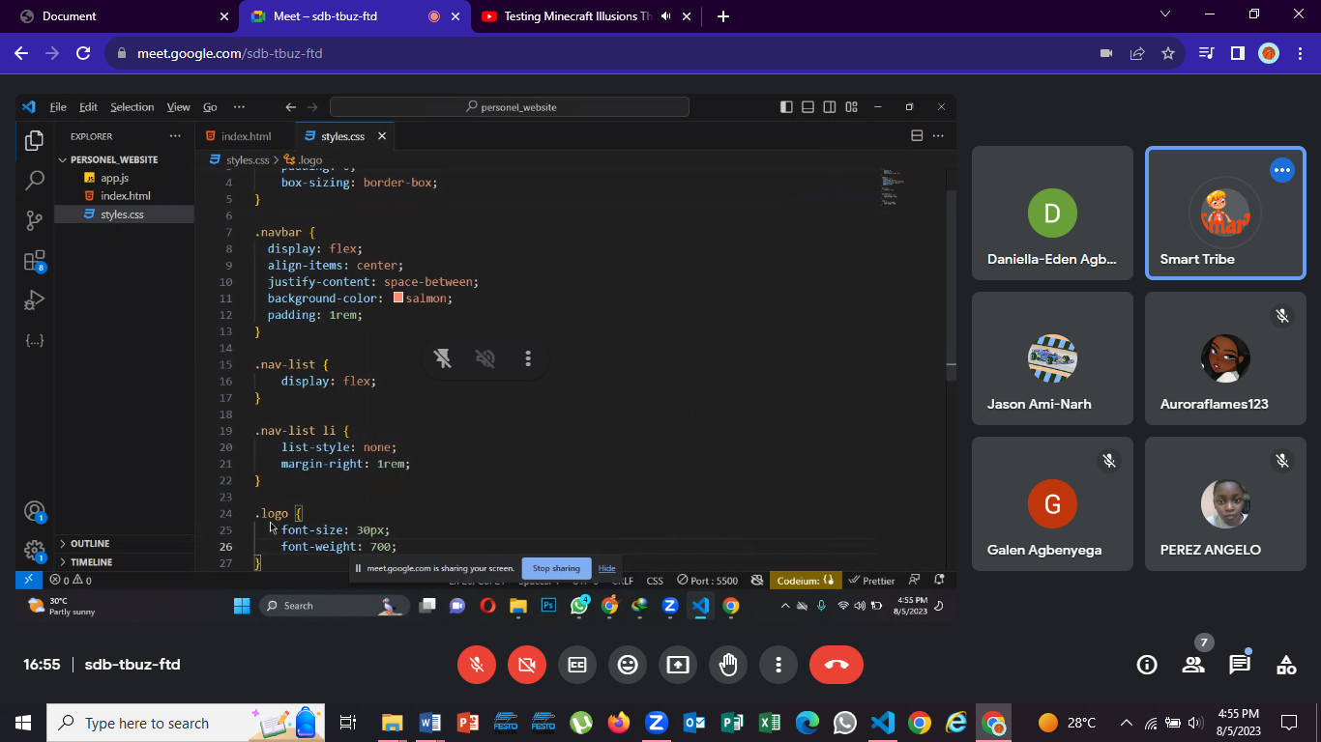 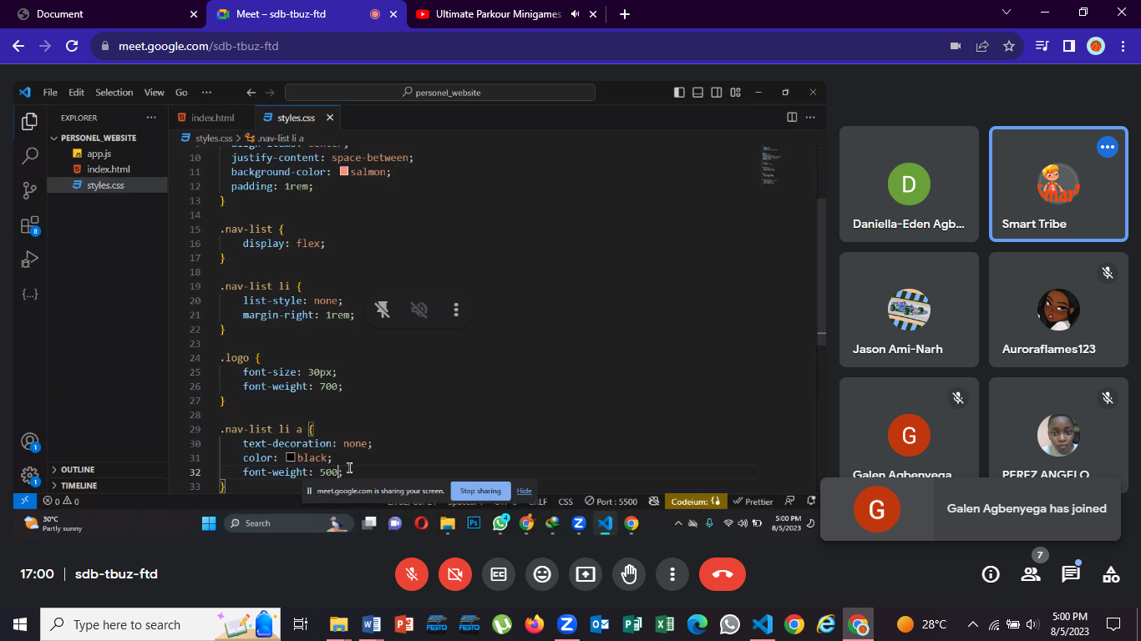

21 n